Q1. Temperature class

|  |
| --- |
| package Q1;  class Temperature {   private double celcius;    public Temperature()  {  this.celcius = 0.0;  }  public Temperature(double celsius)  {  this.celcius=celsius;   }  public double tocelsius()  {  return celcius;  }  public double toFahrenheit()  {  return (celcius*9/5)+32;  }  public void setCelsius(double celsius)  {  this.celcius=celsius;  }  public void setFahrenheit(double fahrenheit)  {  this.celcius=(fahrenheit-32)*5/9;  } } |

Main class

|  |
| --- |
| package Q1;  import java.util.Scanner;  public class Main {  public static void main(String[] args) {  Scanner scanner=new Scanner(System.*in*);  System.*out*.println("Enter the temperature in Celsius: ");   double celsius=scanner.nextDouble();  Temperature t1=new Temperature(celsius);  System.*out*.println("Temperature in Celsius: "+t1.tocelsius());  System.*out*.println("Temperature in Fahrenheit: "+t1.toFahrenheit());  } } |

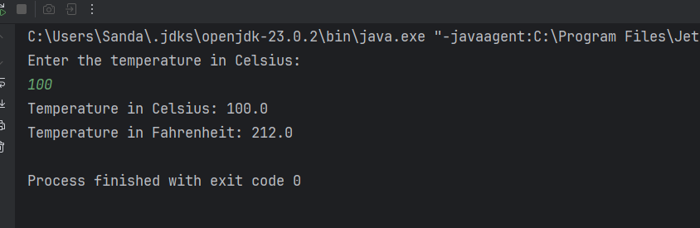

Q2.

|  |
| --- |
| package Q1;  import java.util.Scanner;  public class Main {  public static void main(String[] args) {  Scanner scanner=new Scanner(System.*in*);  System.*out*.println("Enter the temperature in Celsius: ");   double celsius=scanner.nextDouble();  Temperature t1=new Temperature(celsius);  System.*out*.println("Temperature in Celsius: "+t1.tocelsius());  System.*out*.println("Temperature in Fahrenheit: "+t1.toFahrenheit());   System.*out*.println("Enter the temperature in Fahrenheit: ");  double inputFahrenheit=scanner.nextDouble();  Temperature t2=new Temperature();  t2.setFahrenheit(inputFahrenheit);   System.*out*.println("Temperature in Celsius: "+t2.tocelsius());         } } |

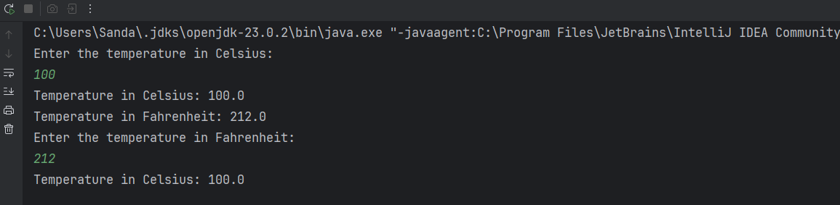

Q3.

Main class

|  |
| --- |
| package Q3;  import java.util.Scanner;  public class Main {  public static void main(String[] args) {   Scanner scanner=new Scanner(System.*in*);   System.*out*.println("Enter the radius of the middle circle: ");  double ri=scanner.nextDouble();  System.*out*.println("Enter the radius of the outer circle: ");  double ro=scanner.nextDouble();   Circle c1= new Circle(ri);  Circle c2= new Circle(ro);  double area = c2.computeArea()-c1.computeArea();   System.*out*.println("Area of the ring: "+area);     System.*out*.println("Circumference of inner Circle:"+c1.computeCircumference());  System.*out*.println("Circumference of outer Circle:"+c2.computeCircumference());    } } |

Circle class

|  |
| --- |
| package Q3;  class Circle {  private double radius;   public Circle() {  this.radius = 0.0;   }   public Circle(double radius) {  this.radius = radius;      }  public double computeArea()  {  return Math.*PI*\*radius*radius;  }   public double computeCircumference()  {  return 2*Math.*PI*\*radius;  }   } |

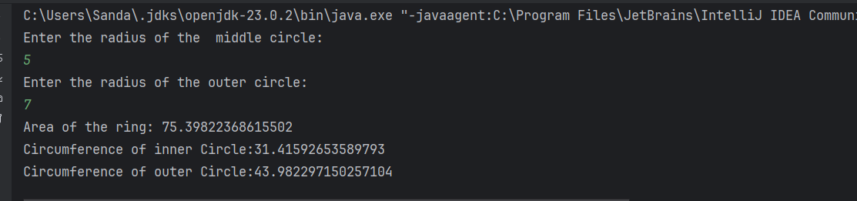

Q4.

Owner class

|  |
| --- |
| package Q4;  public class Owner {  private String ownerName;  private String phoneNo;    public Owner(String name, String num) {  this.ownerName=name;  this.phoneNo=num;  }   public String getOwnerName() {  return ownerName;  }   public String getPhoneNo() {  return phoneNo;  }   public void setOwnerName(String name) {  this.ownerName=name;  }   public void setPhoneNo(String num) {  this.phoneNo=num;  }   } |

Bicycle class

|  |
| --- |
| package Q4;  public class Bicycle {  // Data Member  private Owner owner;  //Constructor: Initializes the data member  public Bicycle() {  this.owner=new Owner("Unknown","Unknown");  }  public Bicycle(String name,String num) {  this.owner=new Owner(name,num);  }   public Owner getOwner() {  return owner;  }  public void setOwner(Owner owner) {  this.owner = owner;    }} |

Main class

|  |
| --- |
| package Q4;   public class Main {  public static void main(String[] args) {   Bicycle bike1 = new Bicycle("John","1234567890");   System.*out*.println("Owner Name: "+bike1.getOwner().getOwnerName());  System.*out*.println("Phone Number: "+bike1.getOwner().getPhoneNo());    } } |

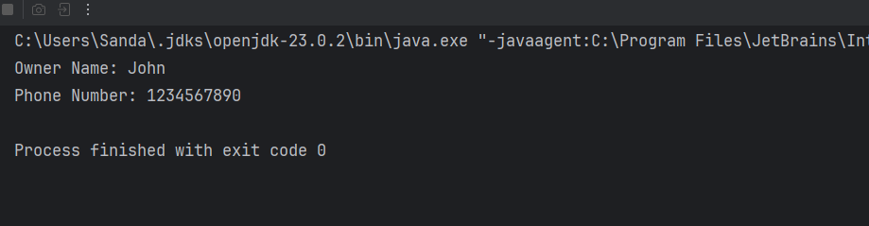

Q5.

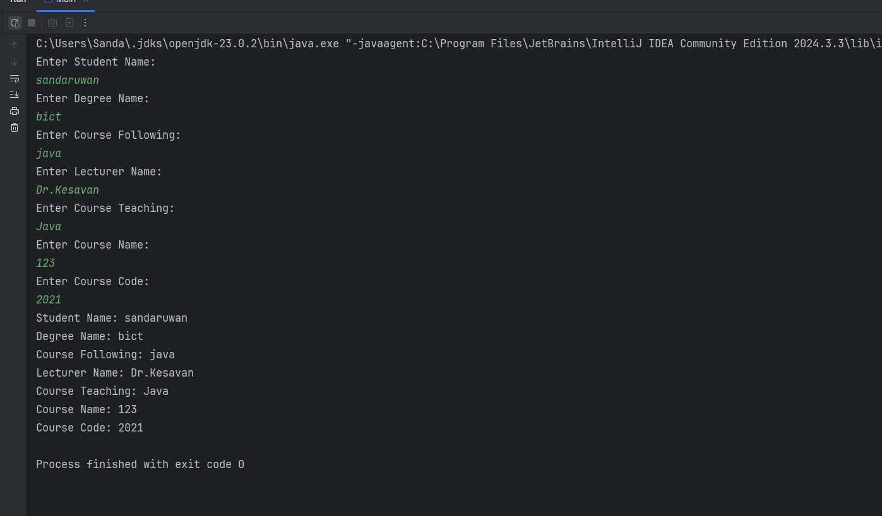

Main class

|  |
| --- |
| package Q5;  import java.util.Scanner;  public class Main {  public static void main(String[] args) {   Scanner scanner = new Scanner(System.*in*);  System.*out*.println("Enter Student Name: ");  String studentName = scanner.nextLine();  System.*out*.println("Enter Degree Name: ");  String degreeName = scanner.nextLine();  System.*out*.println("Enter Course Following: ");  String courseFollowing = scanner.nextLine();   Student student = new Student(studentName, degreeName, courseFollowing);   System.*out*.println("Enter Lecturer Name: ");   String lecturerName = scanner.nextLine();  System.*out*.println("Enter Course Teaching: ");  String courseTeaching = scanner.nextLine();   Lecturer lecturer = new Lecturer(lecturerName, courseTeaching);   System.*out*.println("Enter Course Name: ");  String courseName = scanner.nextLine();  System.*out*.println("Enter Course Code: ");  String courseCode = scanner.nextLine();   Course course = new Course(courseName, courseCode);    System.*out* .println("Student Name: " + student.getStudentName());  System.*out*.println("Degree Name: " + student.getDegreeName());  System.*out*.println("Course Following: " + student.getCourseFollowing());   System.*out*.println("Lecturer Name: " + lecturer.getLecturerName());  System.*out*.println("Course Teaching: " + lecturer.getCourseTeaching());   System.*out*.println("Course Name: " + course.getCourseName());  System.*out*.println("Course Code: " + course.getCourseCode());         }  } |
|  |
|  |

Course class

|  |
| --- |
| package Q5;  class Course {  private String courseName;  private String courseCode;   public Course(String courseName, String courseCode){  this.courseName=courseName;  this.courseCode=courseCode;  }   public String getCourseName() {  return courseName;  }  public String getCourseCode() {  return courseCode;  }  public void setCourseName(String courseName) {  this.courseName = courseName;  }  public void setCourseCode(String courseCode) {  this.courseCode = courseCode;  }  } |

Student Class

|  |
| --- |
| package Q5;  public class Student {  private String studentName;  private String degreeName;  private String courseFollowing;   public Student(String studentName, String degreeName, String courseFollowing) {  this.studentName = studentName;  this.degreeName = degreeName;  this.courseFollowing = courseFollowing;  }   public String getStudentName() {  return studentName;  }  public String getDegreeName() {  return degreeName;  }  public String getCourseFollowing() {  return courseFollowing;  }  public void setStudentName(String studentName) {  this.studentName = studentName;  }  public void setDegreeName(String degreeName) {  this.degreeName = degreeName;  }  public void setCourseFollowing(String courseFollowing) {  this.courseFollowing = courseFollowing;  }    } |

Lecturer class

|  |
| --- |
| package Q5;  public class Lecturer {  private String lecturerName;  private String courseTeaching;   public Lecturer(String lecturerName,String courseTeaching){  this.lecturerName=lecturerName;  this.courseTeaching=courseTeaching;  }    public String getLecturerName() {  return lecturerName;  }  public String getCourseTeaching(){  return courseTeaching;  }  public void setLecturerName(String lecturerName) {  this.lecturerName = lecturerName;  }  public void setCourseTeaching(String courseTeaching) {  this.courseTeaching = courseTeaching;  } } |